Setting up the stores eligible to receive a certain style(s)

APTOS Merchandising>Allocation & Replenishment>Table maintenance>Location Eligibility

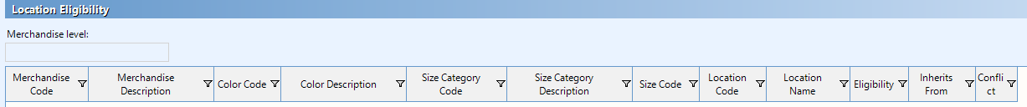

Select ‘Table’ from menu and ‘Query’

* Query box will pop-up
* These selections assist in defining the criteria to use

Query box

Choose you merchandise level

* BAB always uses style

Location criteria: used to determine the locations

Color criteria: BAB does not use

Size criteria: BAB does not use

To make a location eligible to receive system generated units for selected style the ‘Eligibility’ box needs to be checked

Setting up the min-max profiles for to receive a certain style(s)

APTOS Merchandising>Allocation & Replenishment>Table maintenance>Min Max profiles

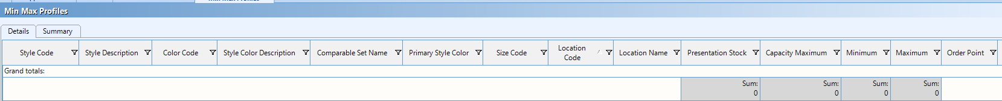

Select ‘Table’ from menu and ‘Query’

* Query box will pop-up
* These selections assist in defining the criteria to use

Query box

Choose you merchandise level

* BAB always uses style

Location criteria: used to determine the locations

There are three fields on this screen mandatory to fill out BAB deems necessary to ensure distribution documents are created

Presentation stock: number of units a location should maintain for a style for presentation and/or in-store displays

Include Presentation Stock with Order Point: combine presentation stock with order point criteria to determine whether a store should be added to a distribution document

* box needs to be checked

Dynamic Start Date: when to begin using criteria to create min-max profiles for a style for a location

